**VPC – Virtual Private Cloud**

Ability for customer to create private network space on top of amazon network

Launched in Dec-2013. Before that instances are secured with security group

EC2 Classic – EC2 instance running out of VPC

VPC is within a region. It cannot be between regions

VPC is with a region between multiple Availability Zones

Tenancy applies for VPC. If selected to be in a dedicated host, VPC will be created in a dedicated host

VPCs are not global network. They are regional network that span in multiple availability zones

VPC comes with internal DNS Option. We can ignore it and create our own DNS Server and have our own name for the Instances

Web Browser 🡪 Open Internet 🡪 Internet Gateway 🡪 VPC

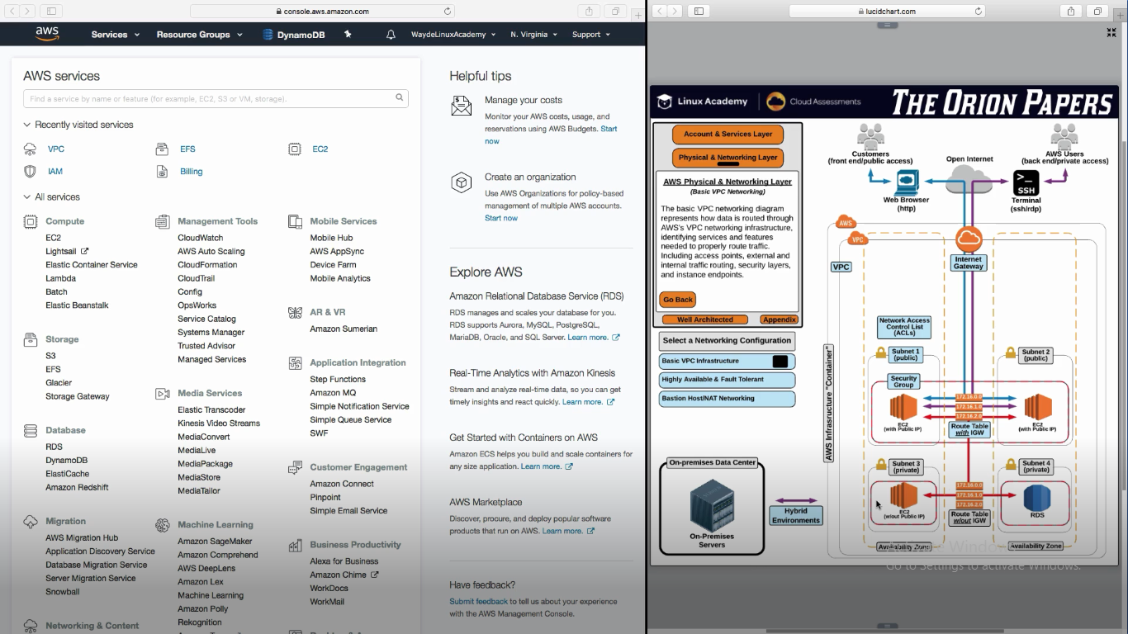

**Internet gateway** helps in communication from outside internet to VPC

It is one to one mapping with VPC

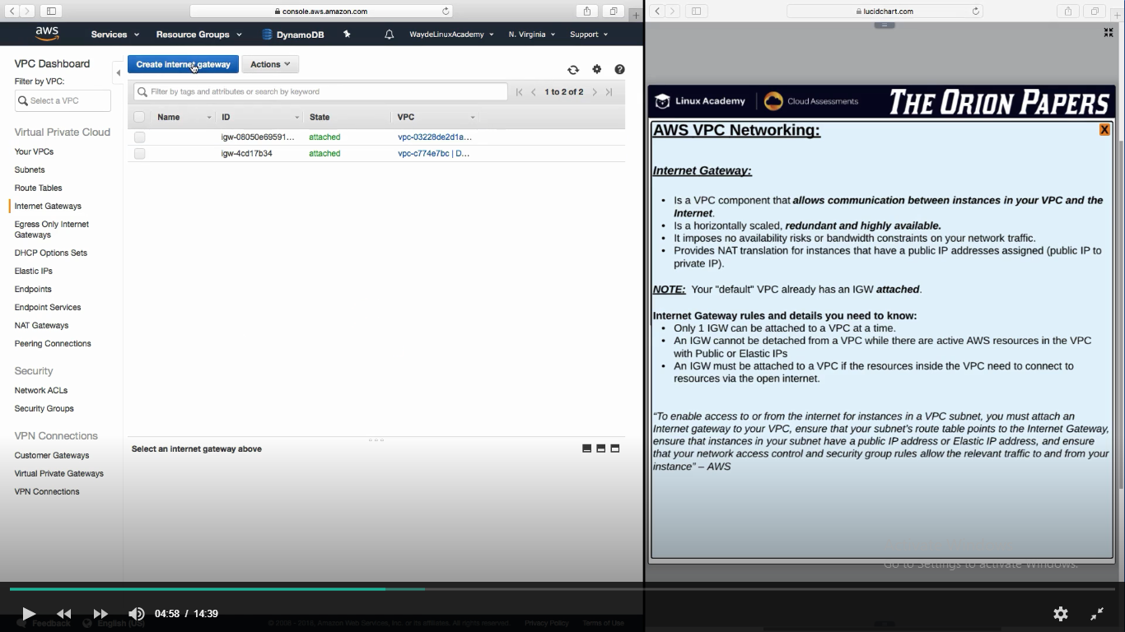

**VPC have Virtual Private Gateway**

Attach the virtual private gateway to your VPC. You can make a hardware based VPN connection from your data center straight to our VPC. This allows extending your corporate network into AWS like its one single network. This is a hybrid environment.

Creating a VPC, automatically assigns an ip and DNS name.

If we don’t want to use that internal DNS server , we can use DHCP option (Dynamic Host Configuration Protocol) so that we can have our own DNS name for the instance

**What is CIDR**

Classless Inter Domain routing

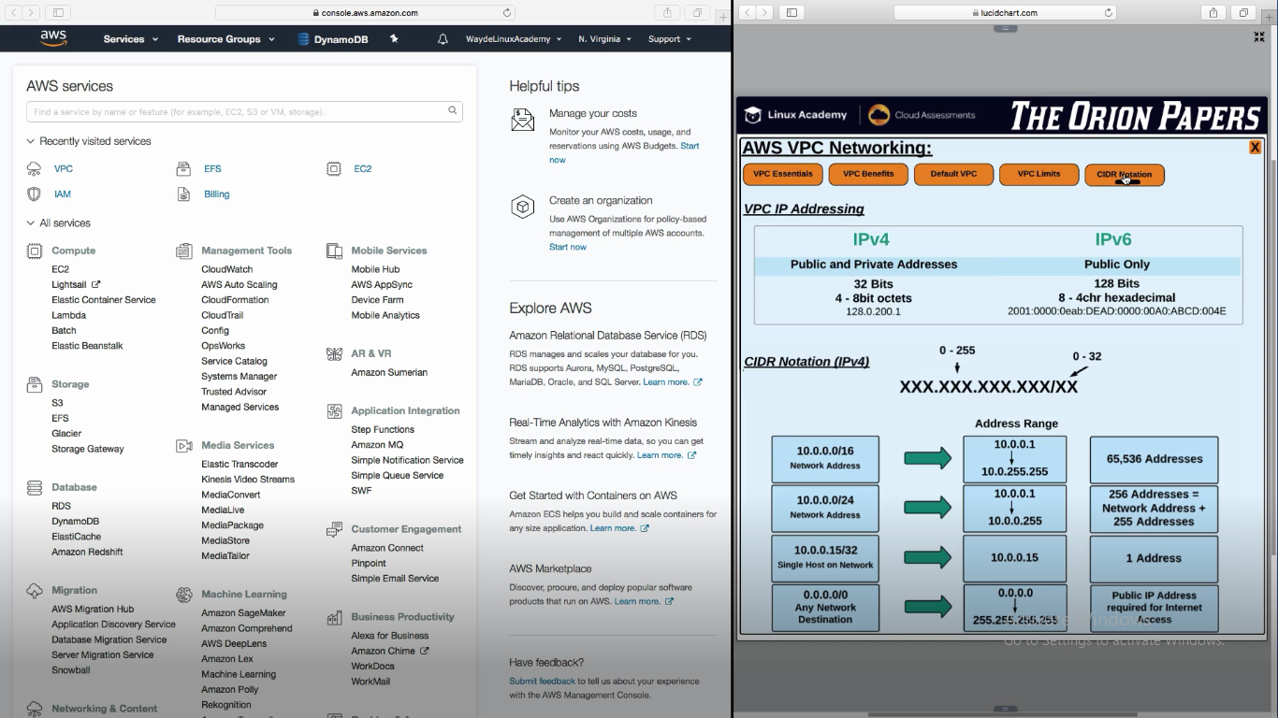

IP Ranges from: 0.0.0.0 to 255.255.255.255

Private subnet ip range : 10.0.0.0 to 10.255.255.255

AWS ip address to be used for vpc

172.16.0.0 172.31.255.255

192.168.0.0. 192.168.255.255

10.0.0.0 to 10.255.255.255

**Benefits of VPC**

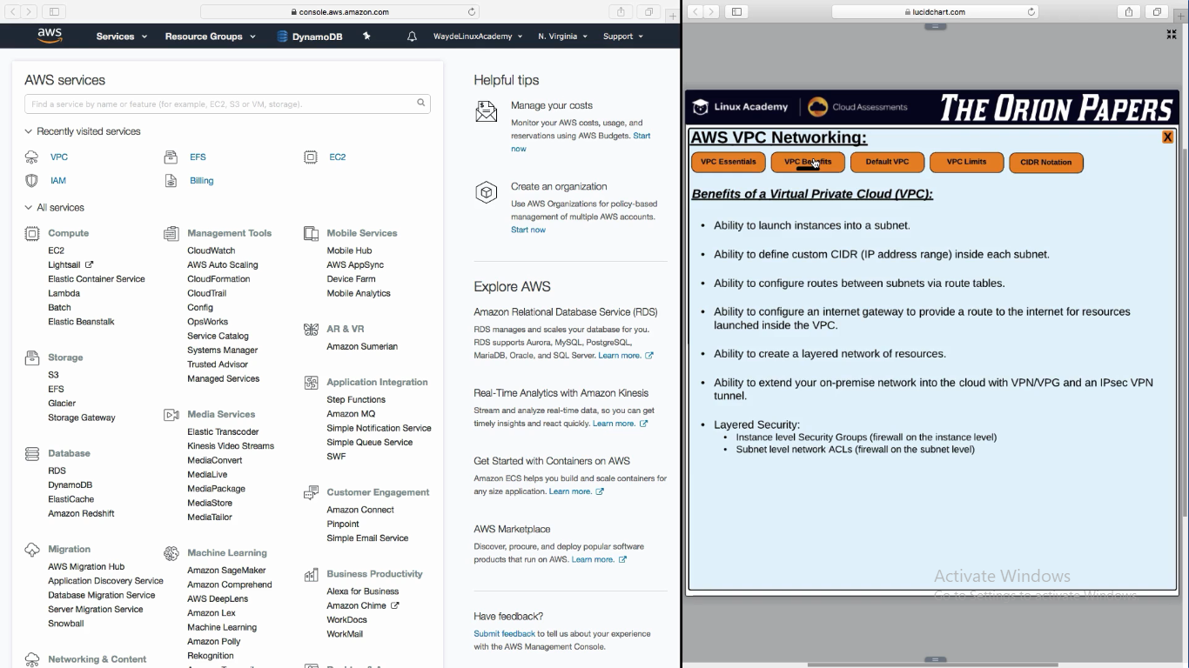

**Default VPC**

All these limits are soft. We have to contact AWS support to increase it

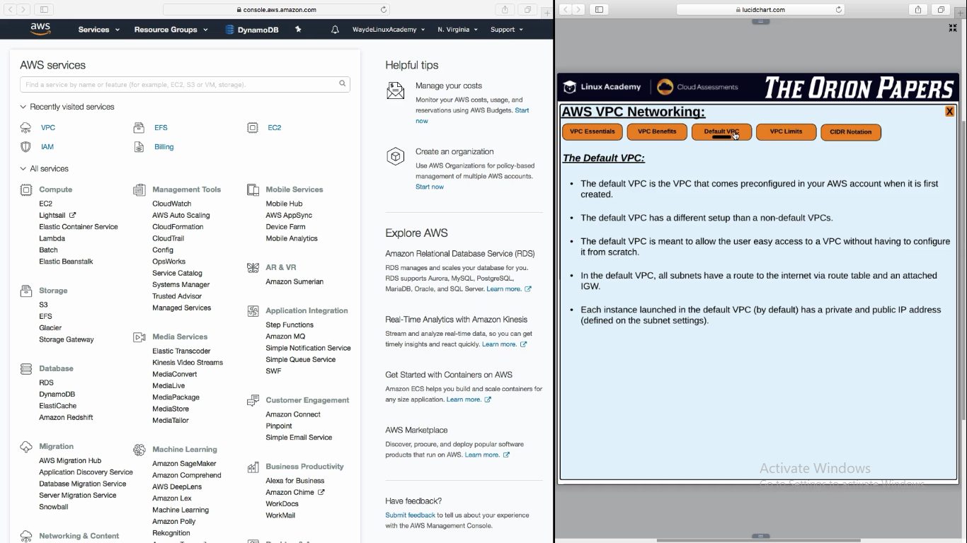

**Subnet Creation**

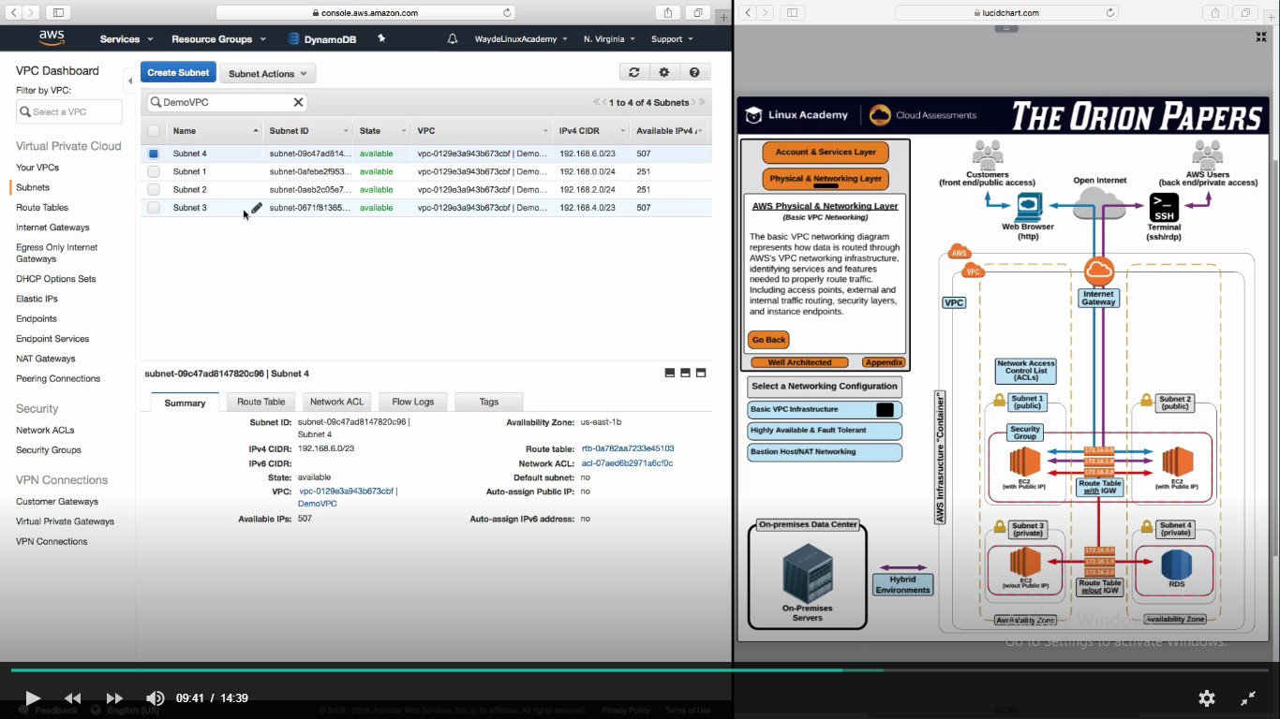

**Route Table**

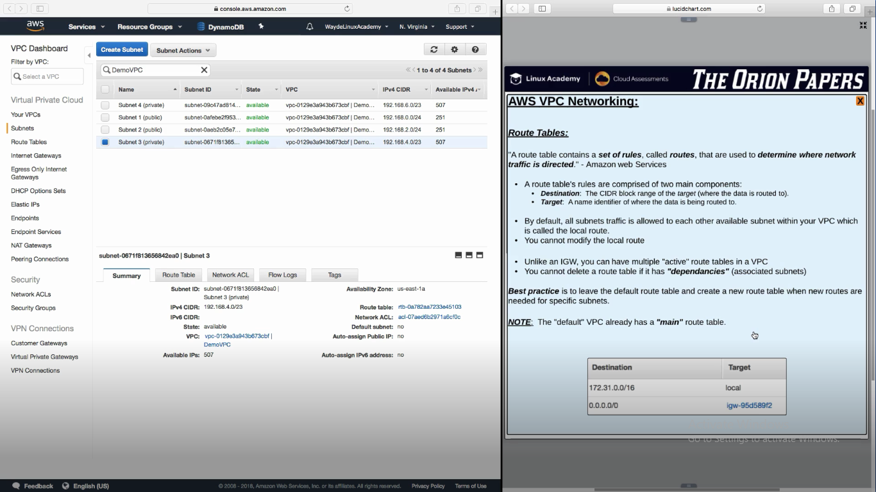

Create a Route Table and associate it to VPC

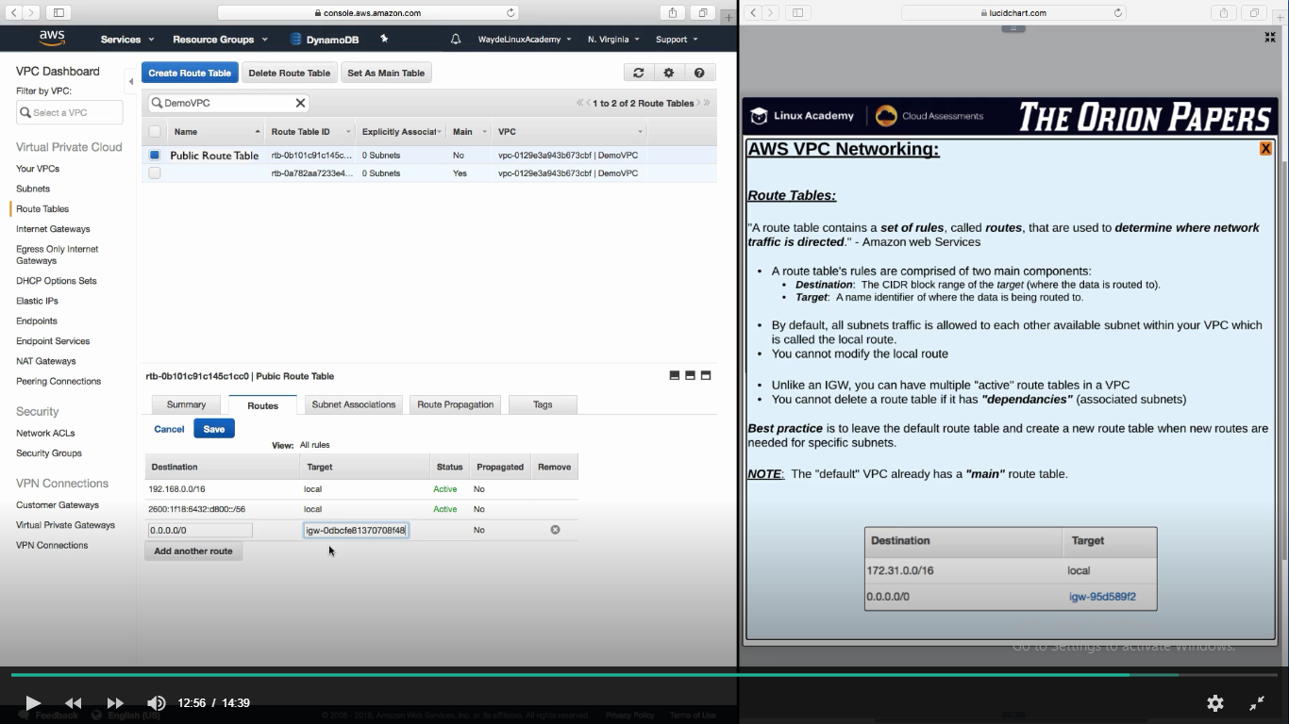

Route Table 🡪 Set routes destination and target. Target is the internet Gateway

Route Table 🡪 Map the subnets

**Security Level in VPC**

NACL is two way because they are stateless – inbound and outbound

We can add allow and deny rules in NACL

NACL is associated with Subnets

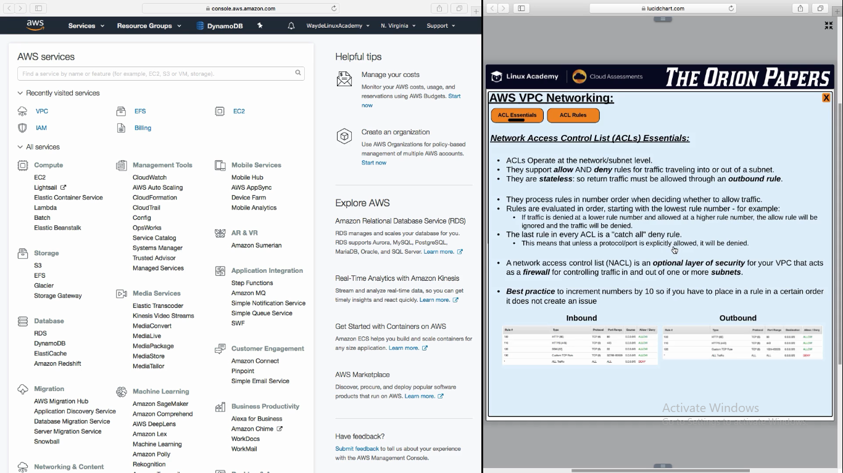

**NACL Configurations**

We will set both inbound and outbound rules

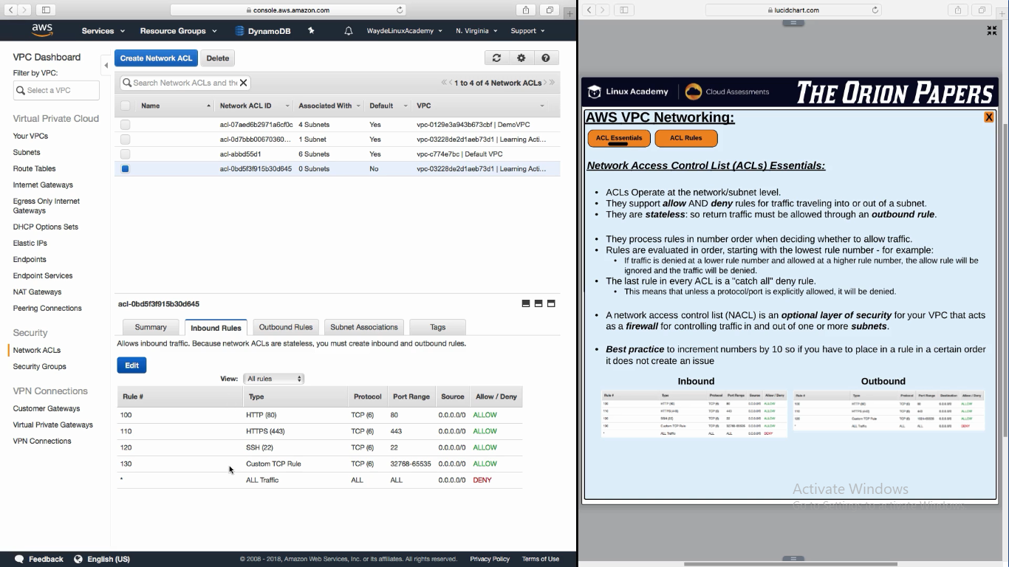

**NACL Associated to subnets**

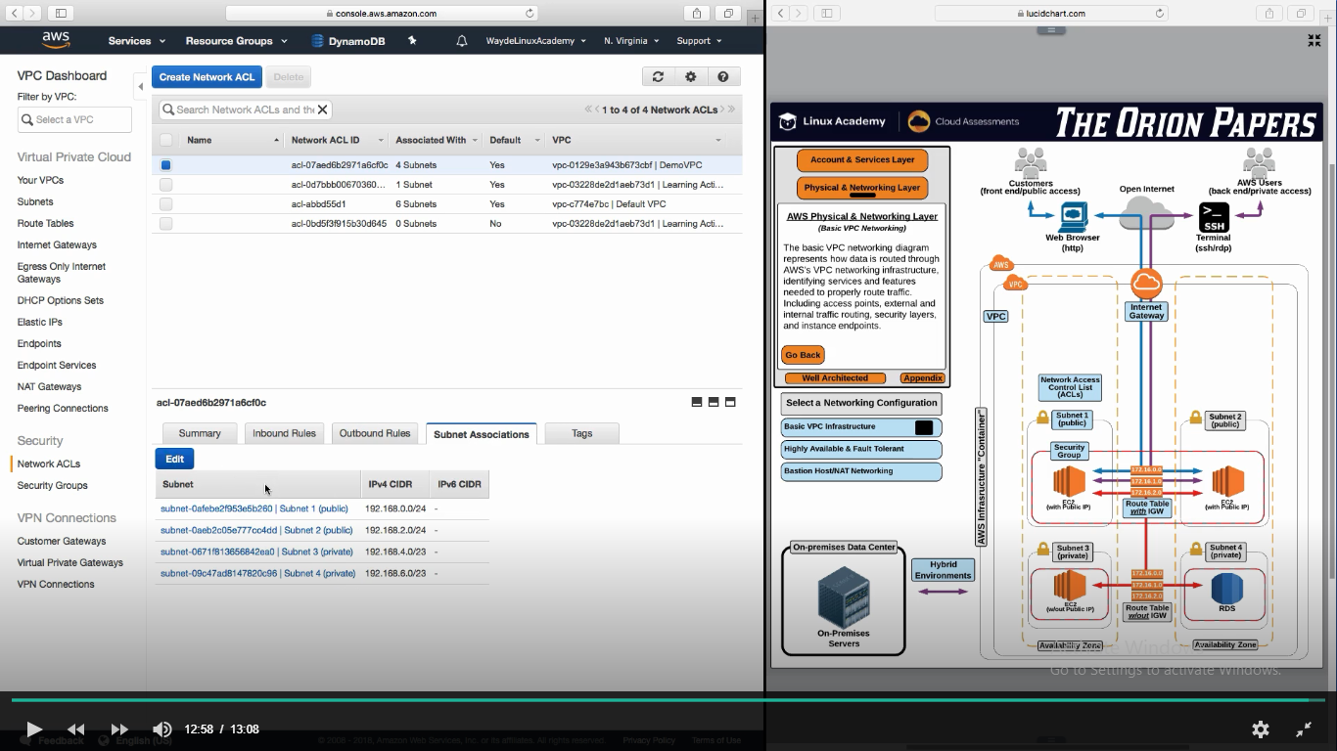

**Control comes from NACL to SG**

We will set only in bound rules for SG. Because they are stateful

SG is associated to instances

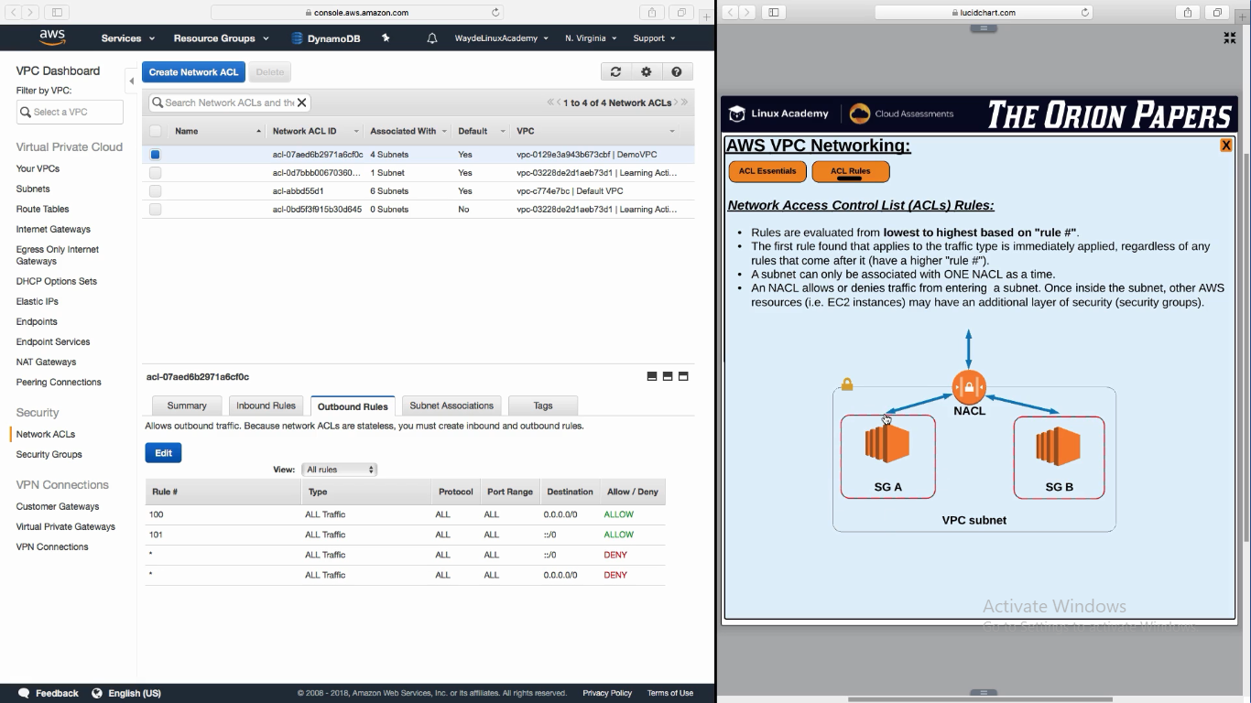

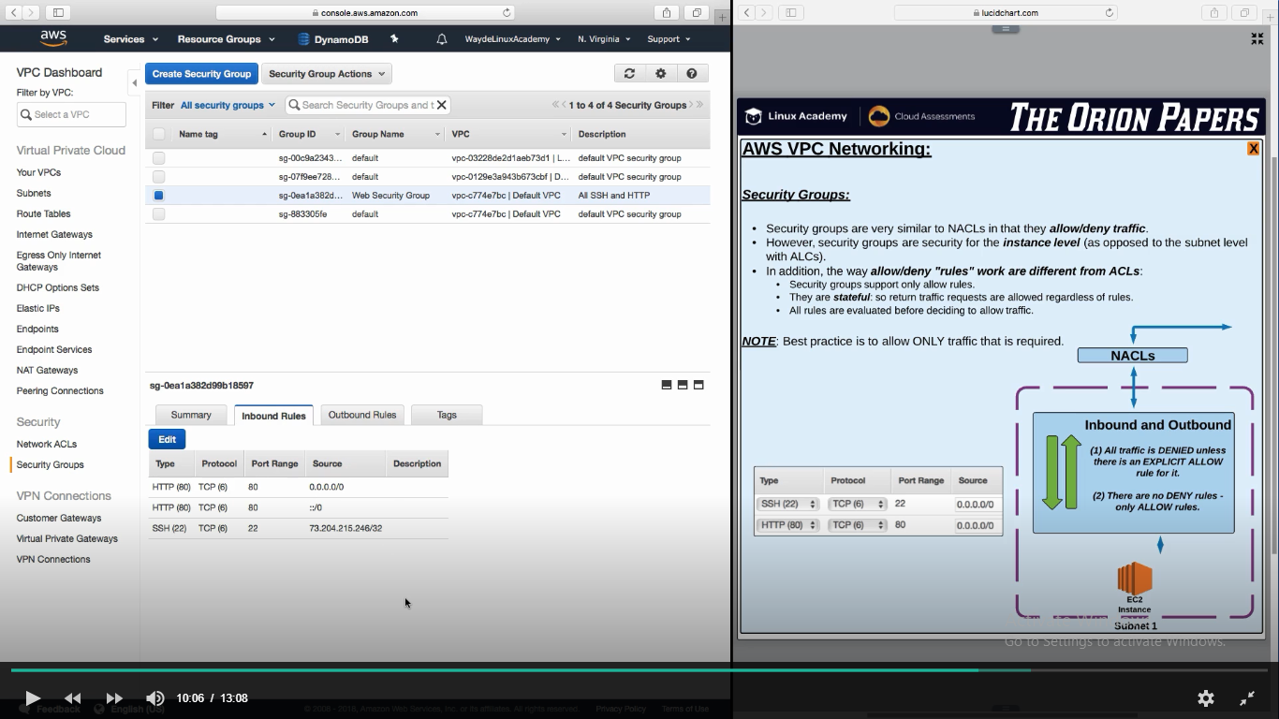

**Reference**

For basic information on NAT Gateways, see: <https://docs.aws.amazon.com/vpc/latest/userguide/vpc-nat-gateway.html#nat-gateway-basics>

Security is something you always need to be thinking about when setting up your networking architecture. This lesson covers AWS's two core networking security features: network access control lists and security groups.

Correction: "Network ACLs are stateless; responses to allowed inbound traffic are subject to the rules for outbound traffic (and vice versa)."*

* <https://docs.aws.amazon.com/vpc/latest/userguide/vpc-network-acls.html>
* For more on ephemeral ports and NACLs, see: <https://docs.aws.amazon.com/vpc/latest/userguide/vpc-network-acls.html#nacl-ephemeral-ports>

**Creating our own VPC:**

1. Console -> Network and content delivery -> VPC -> create VPC
2. Give name of VPC and give the CIDR ip address range
3. Dedicated means host server is dedicate for our ec2 instance

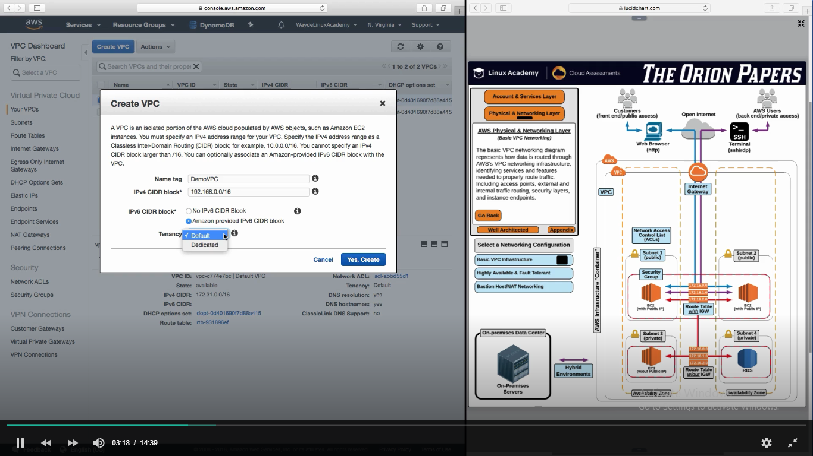

**Create Internet Gateway**

1. Console -> VPC -> Internet Gateway -> Create Internet Gateway
2. Give a name -> create
3. It will be in detached mode. Attach it to VPC and select the VPC name

**Create Subnet**

1. Console -> VPC -> subnets -> create subnet
2. Give a name and select the VPC . It will show the CIDR ip range associated for VPC
3. Select AZ1
4. Give IP Address range in CIDR. It will be assigned to instances being launched inside the subnet

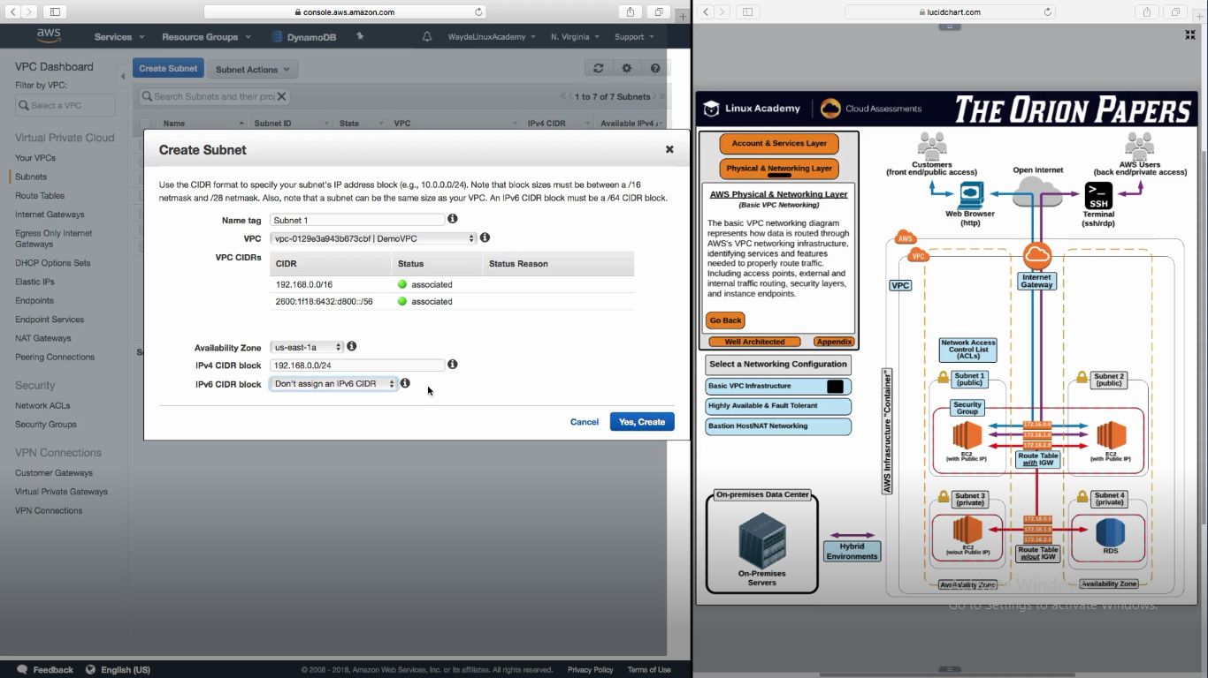

1. Create Subnet 2 in another AZ2



1. Create private subnet 3 in AZ1. Ip range is big as we need many private instances

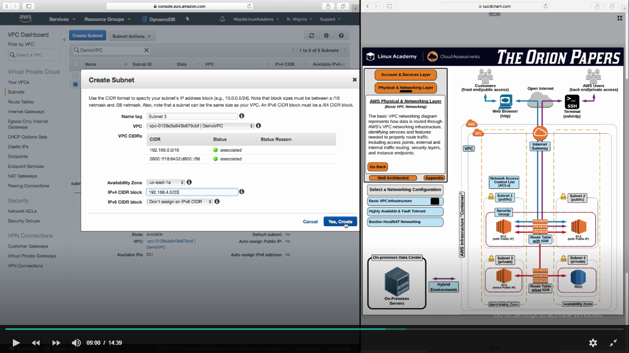

1. Create private subnet 4 in AZ2

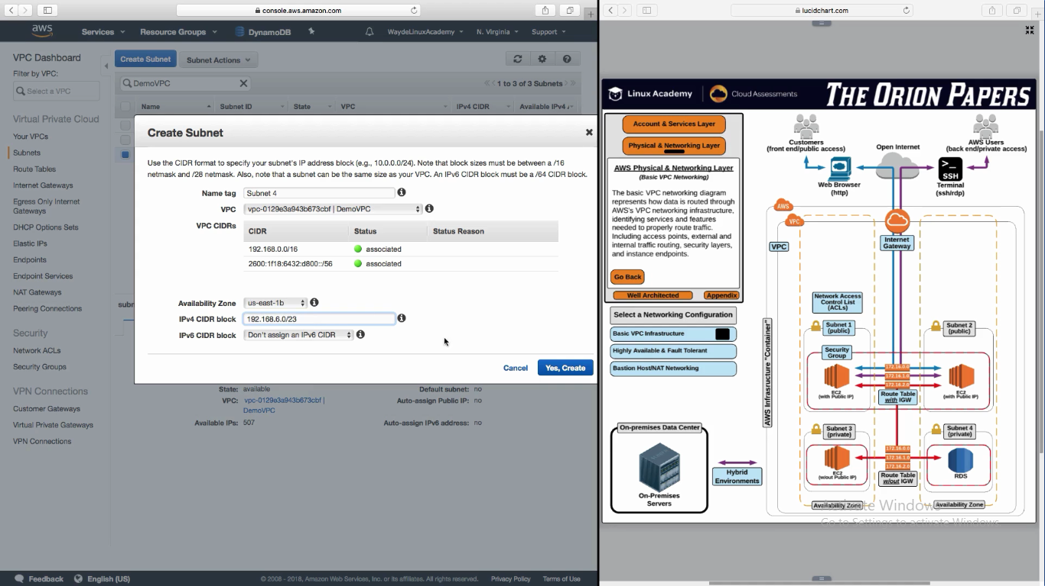

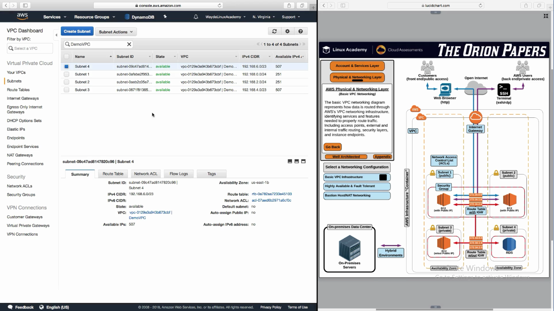

**Create Route Table**

1. Console -> VPC -> Route Table -> Create Route Table
2. We will use it for the two public subnet
3. Edit the custom route table, and add a route to Internet Gateway
   1. Destination is whole internet
   2. Target is Internet Gateway

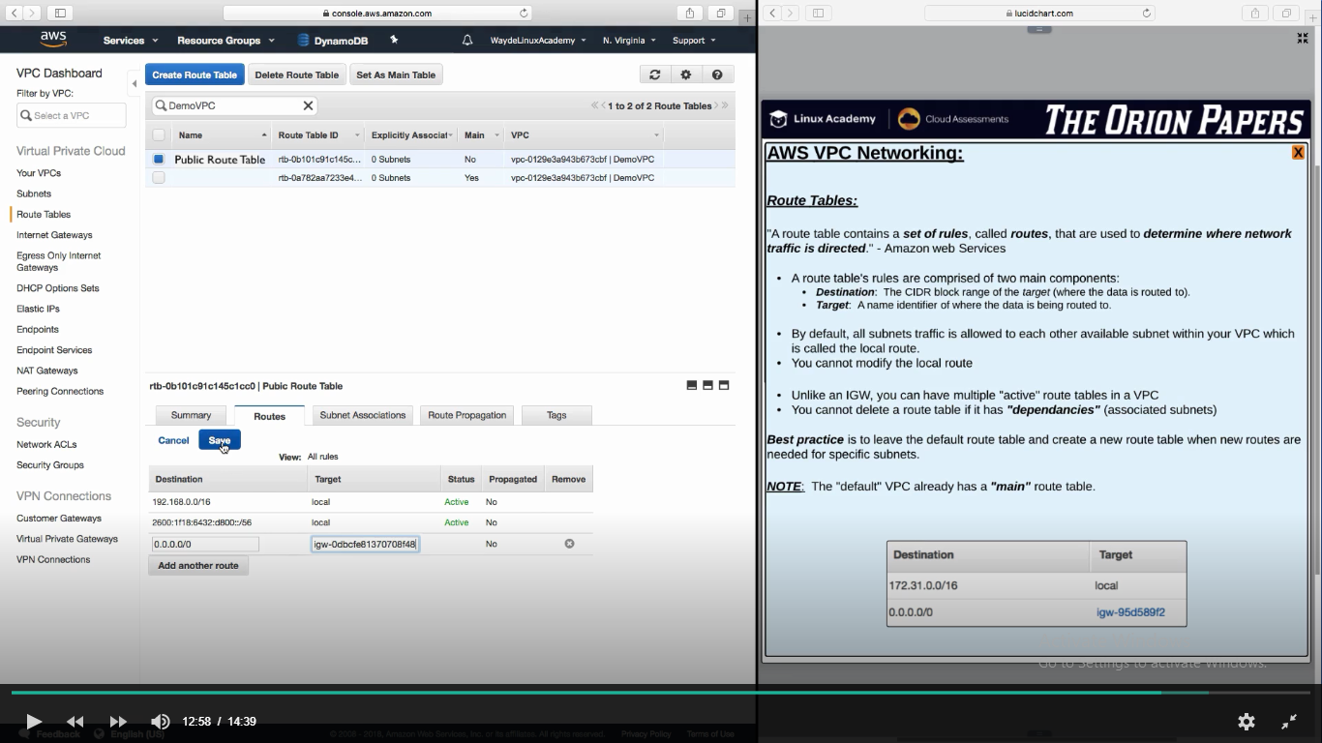

1. Associate the Route Table to subnet
   1. Choose the public subnet

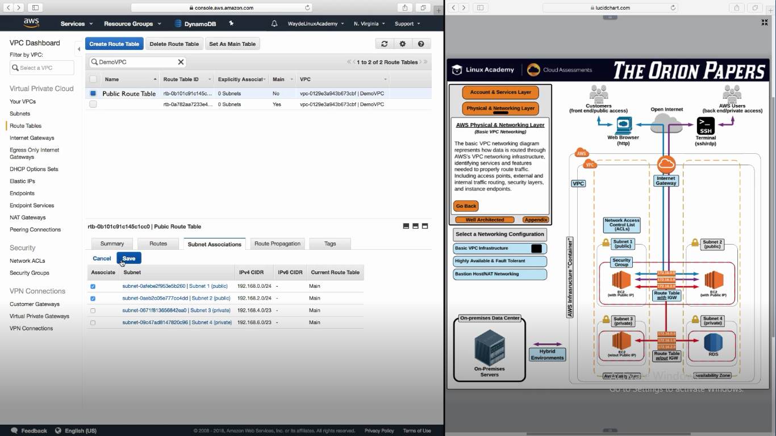

**Route table for Private subnet**

1. Create route table
2. Don’t create new routes. Leave the local routes
3. Associate route table to private subnet
4. 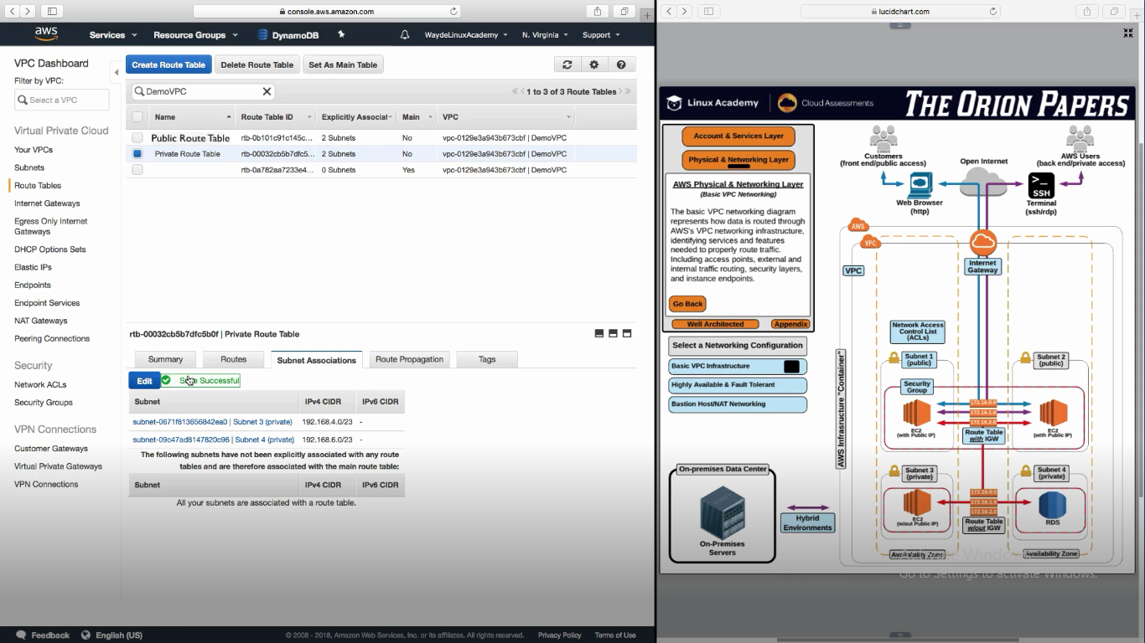Subnet associatae ->

**Security inside VPC**

1. Console -> VPC -> Security -> NACL
2. A default NACL will be created for the VPC we created. By default it will allow all incoming calls
3. Select it and edit it

Inbound

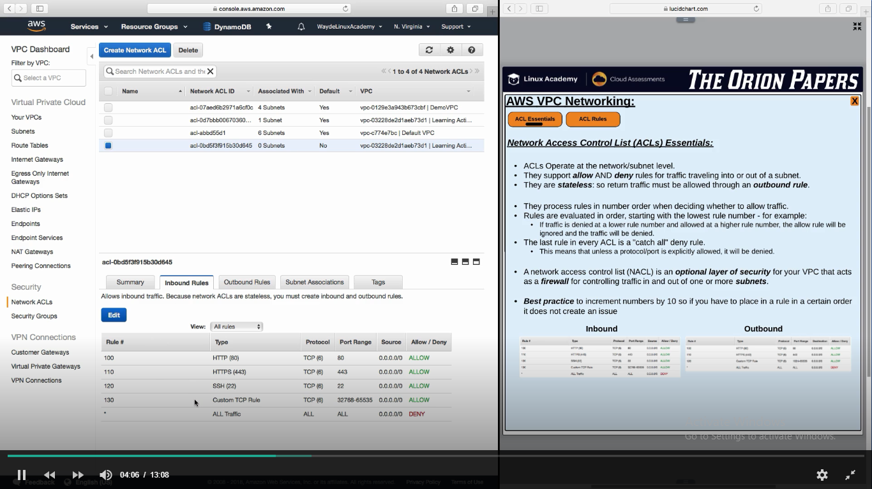

**Outbound Rules:**

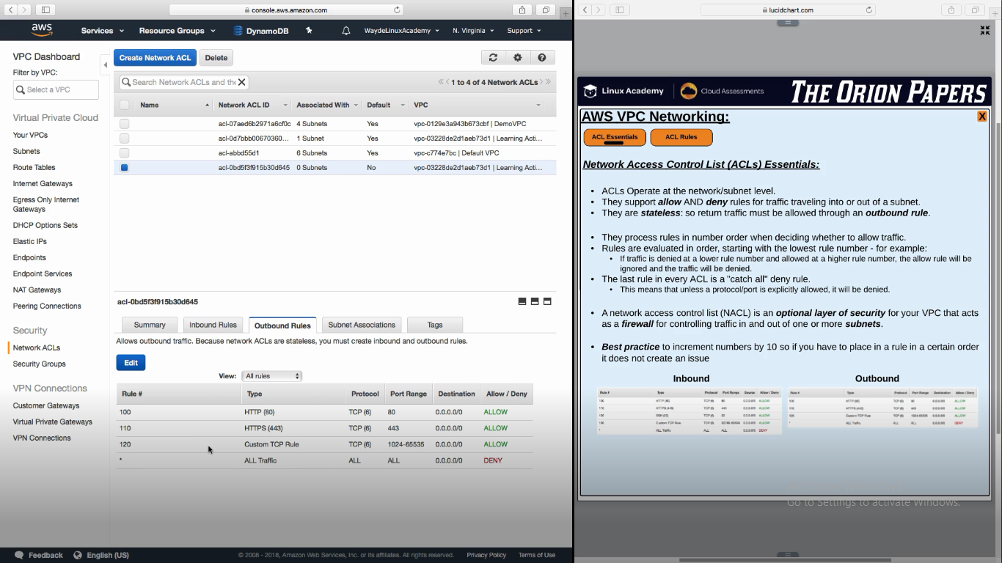

**Create Security Group**

1. Console -> VPC -> Security -> Security Groups
2. Security group is scoped for a VPC
   1. We cannot have a security group mapped for two vpc